**NAME : Gopikrishnan L**

**REG.NO : 230701096**

**DEPT : B E COMPUTER SCIENCE AND ENGINEERING - A**

**Competitive Programming**

* 1. **Finding Duplicates-O(n^2) Time Complexity (1) Space Complexity**

**Aim:** Find Duplicate in Array.

Given a read only array of n integers between 1 and n, ﬁnd one number that repeats. Input Format:

First Line - Number of elements n Lines - n Elements Output Format:

Element x - That is repeated

## Algorithm:

function main()

{

initialize n // Number of elements in the array read n from user

initialize arr[n] // Array to hold input values

// Read values into the array for i from 0 to n - 1

{

read arr[i] from user

}

ﬂag = 0 // Initialize a ﬂag to indicate if a duplicate is found

// Search for the ﬁrst duplicate element for i from 0 to n - 1

{

el1 = arr[i] // Current element

for j from 0 to n - 1

{

// Check for duplicates and ensure indices are different if el1 == arr[j] and i != j

{

print el1 // Print the duplicate element

ﬂag = 1 // Set ﬂag to indicate a duplicate was found break

// Exit inner loop

}

}

if ﬂag

break // Exit outer loop if a duplicate was found

}

}

## Program:

#include<stdio.h>

int main(){ int n;

scanf("%d",&n); int arr[n];

for(int i=0;i<n;i++){ scanf("%d ",&arr[i]);

}

int ﬂag=0;

for(int i=0;i<n;i++){ int el1=arr[i];

for(int j=0;j<n;j++){ if (el1==arr[j] &&

i!=j){

printf("%d",el1); ﬂag=1;

break;

}

}

if(ﬂag

)

break

;

}

}

**Output:**

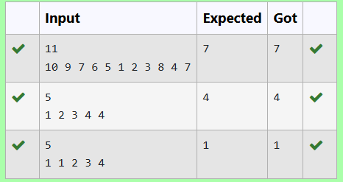

# Finding Duplicates-O(n) Time Complexity (1) Space Complexity

**Aim:** Find Duplicate in Array.

Given a read only array of n integers between 1 and n, ﬁnd one number that repeats. Input Format:

First Line - Number of elements n Lines - n Elements Output Format:

Element x - That is repeated

## Algorithm:

function main()

{

initialize n // Number of elements in the array read n from user

initialize a[n] // Array to hold input values

// Read values into the array for i from 0 to n - 1

{

read a[i] from user

}

initialize b[n] // Array to keep track of seen elements for i from 0 to n - 1

{

b[i] = 0 // Initialize the tracking array

}

// Search for the ﬁrst duplicate element for i from 0 to n - 1

{

// If the element is already present, i.e., b[a[i]] = 1 if b[a[i]]

{

print a[i] // Print the duplicate element break // Exit the loop

}

else

{

b[a[i]] = 1 // Mark the element as seen

}

}

}

## Program:

#include

<stdio.h> int main(){

int n; scanf("%d",&n); int a[n];

for(int i=0;i

<n;i++){

scanf("%d",&a[i]

);

}

int b[n];

for(int i=0;i <n;i++){ b[i]=0;

}

for(int i=0;i<n;i++){

//if el already present i.e, b[i]=1 if(b[a[i]]){

printf("%d",a[i]); break;

}

else b[a[i]]=1;

}

}

**Output:**

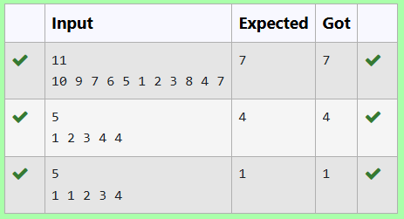

# Print Intersection of 2 sorted

**arrays-O(m*n)Time Complexity,O(1) Space Complexity**

## Aim:

Find the intersection of two sorted arrays. OR in other words,

Given 2 sorted arrays, ﬁnd all the elements which occur in both the arrays. Input Format

· The ﬁrst line contains T, the number of test cases. Following T lines contain:

1. Line 1 contains N1, followed by N1 integers of the ﬁrst array
2. Line 2 contains N2, followed by N2 integers of the second array Output Format

The intersection of the arrays in a single line Example

Input:

1

3 10 17 57

6 2 7 10 15 57 246

Output:

10 57

Input:

1

6 1 2 3 4 5 6

2 1 6

Output:

1 6

## Algorithm:

function main()

{

initialize n // Number of test cases read n from user

for i from 0 to n - 1

{

initialize n1 // Size of the ﬁrst array read n1 from user

initialize arr1[n1] // First array

// Read values into the ﬁrst array for j from 0 to n1 - 1

{

read arr1[j] from user

}

initialize n2 // Size of the second array read n2 from user

initialize arr2[n2] // Second array

// Read values into the second array for j from 0 to n2 - 1

{

read arr2[j] from user

}

// Check for common elements in both arrays for j from 0 to n1 - 1

{

for k from 0 to n2 - 1

{

if arr1[j] == arr2[k]

{

print arr1[j] // Print the common element

}

}

}

}

}

**Program:** #include<stdio. h> int main(){

int n; scanf("%d",&n); for(int i=0;i<n;i++){

int n1; scanf("%d",&n

* 1. ; int arr1[n1]; for(int j=0;j<n1;j++){

scanf("%d ",&arr1[j]);

}

int n2; scanf("%d",&n2);

int arr2[n2];

for(int j=0;j<n2;j++){ scanf("%d ",&arr2[j]);

}

for(int j=0;j<n1;j++){ for(int k=0;k<n2;k++){

if(arr1[j]==arr2[k]){

printf("%d ",arr1[j]);

}

}

}

}

}

**Output:**

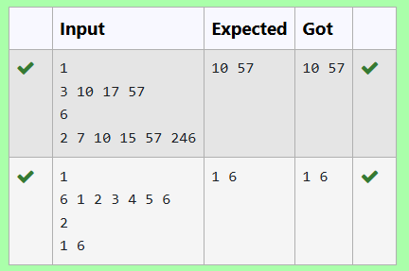

# Print Intersection of 2 sorted

**arrays-O(m+n)Time Complexity,O(1) Space Complexity**

## Aim:

Find the intersection of two sorted arrays. OR in other words,

Given 2 sorted arrays, ﬁnd all the elements which occur in both the arrays. Input Format

· The ﬁrst line contains T, the number of test cases. Following T lines contain:

1. Line 1 contains N1, followed by N1 integers of the ﬁrst array
2. Line 2 contains N2, followed by N2 integers of the second array Output Format

The intersection of the arrays in a single line Example

Input:

1

3 10 17 57

6 2 7 10 15 57 246

Output:

10 57

Input:

1

6 1 2 3 4 5 6

2 1 6

Output:

1 6

## Algorithm:

function main()

{

initialize T // Number of test cases read T from user

while T > 0

{

// Decrement the test case counter T--

initialize n1, n2 // Sizes of the two arrays read n1 from user

initialize arr1[n1] // First array

// Read values into the ﬁrst array for i from 0 to n1 - 1

{

read arr1[i] from user

}

read n2 from user

initialize arr2[n2] // Second array

// Read values into the second array for i from 0 to n2 - 1

{

read arr2[i] from user

}

initialize i = 0, j = 0 // Indices for both arrays

// Iterate through both arrays to ﬁnd common elements while i < n1 and j < n2

{

if arr1[i] < arr2[j]

{

i++ // Move to the next element in arr1

}

else if arr2[j] < arr1[i]

{

j++ // Move to the next element in arr2

}

else

{

print arr1[i] // Print the common element i++

// Move to the next element in arr1 j++ // Move to the next element in arr2

}

}

print new line // Move to the next line for output

}

}

## Program:

#include <stdio.h>

int main()

{ int T; scanf("%d", &T);

while (T--) { int n1, n2;

scanf("%d", &n1); int arr1[n1];

for (int i = 0; i < n1; i++) { scanf("%d", &arr1[i]);

}

scanf("%d", &n2); int arr2[n2];

for (int i = 0; i < n2; i++) { scanf("%d", &arr2[i]);

}

int i = 0, j = 0;

while (i < n1 && j < n2) { if (arr1[i] < arr2[j]) {

i++;

}

else if (arr2[j] < arr1[i]) { j++;

}

else {

printf("%d ",

arr1[i]); i++; j++;

}

}

printf("\n");

}

}

**Output:**

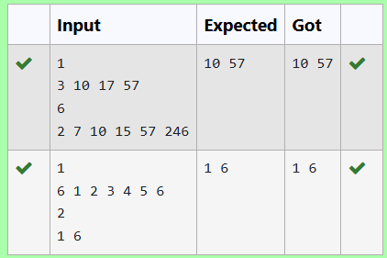

# Pair with Difference-O(n^2)Time Complexity,O(1) Space Complexity

## Aim:

Given an array A of sorted integers and another non negative integer k, ﬁnd if there exists 2 indices i and j such that A[j] - A[i] = k, i != j.

Input Format:

First Line n - Number of elements in an array Next n Lines - N elements in the array

k - Non - Negative Integer Output Format:

1 - If pair exists

0 - If no pair exists

Explanation for the given Sample Testcase: YES as 5 - 1 = 4

So Return 1.

## Algorithm:

function main()

{

initialize n // Number of elements in the array read n from user

initialize arr[n] // Array to hold input values

// Read values into the array for i from 0 to n - 1

{

read arr[i] from user

}

initialize t // Target difference read t from user

initialize ﬂag = 0 // Flag to indicate if a pair is found

// Check for pairs with the speciﬁed difference for i from 0 to n - 1

{

for j from 0 to n - 1

{

if i != j and abs(arr[i] - arr[j]) == t

{

ﬂag = 1 // Pair found break

}

}

if ﬂag

{

break

}

}

// Output the result based on the ﬂag if ﬂag

{

print 1 // Pair found

}

else

{

print 0 // No pair found

}

return 0

}

## Program:

#include

<stdio.h> #include

<stdlib.h>

int main()

{ int n; scanf("%d", &n);

int arr[n];

for (int i = 0; i < n; i++) { scanf("%d", &arr[i]);

}

int t; scanf("%d", &t);

int ﬂag = 0;

for (int i = 0; i < n; i++) { for (int j = 0; j < n; j++)

{

if (i!=j && abs(arr[i] - arr[j]) == t) { ﬂag = 1;

break;

}

}

if (ﬂag)

{

break

;

}

}

if (ﬂag) {

printf("%d\n", 1);

} else {

printf("%d\n", 0);

}

return 0;

}

**Output:**

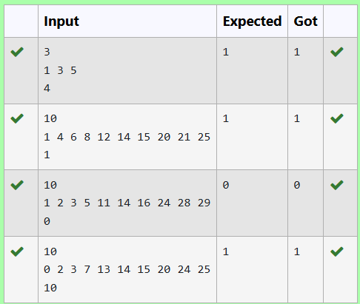

# Pair with Difference -O(n) Time Complexity,O(1) Space Complexity

**Aim:** Given an array A of sorted integers and another non negative integer k, ﬁnd if there exists 2 indices i and j such that A[j] - A[i] = k, i != j.

Input Format:

First Line n - Number of elements in an array Next n Lines - N elements in the array

k - Non - Negative Integer Output Format:

1 - If pair exists

0 - If no pair exists

Explanation for the given Sample Testcase: YES as 5 - 1 = 4

So Return 1.

## Algorithm:

function main()

{

initialize n // Number of elements in the array read n from user

initialize arr[n] // Array to hold input values

// Read values into the array for i from 0 to n - 1

{

read arr[i] from user

}

initialize t // Target difference read t from user

initialize ﬂag = 0 // Flag to indicate if a pair is found

initialize i = 0 // First index initialize j = 1 // Second index

// Loop to ﬁnd pairs with the speciﬁed difference while i < n and j < n

{

diff = abs(arr[i] - arr[j]) // Calculate the difference

if i != j and diff == t

{

ﬂag = 1 // Pair found break

}

else if diff < t

{

j++ // Increment second index

}

else

{

i++ // Increment ﬁrst index

}

}

// Output the result based on the ﬂag if ﬂag

{

print 1 // Pair found

}

else

{

print 0 // No pair found

}

return 0

}

## Program:

#include

<stdio.h> #include

<stdlib.h>

int main()

{ int n; scanf("%d", &n);

int arr[n];

for (int i = 0; i < n; i++) { scanf("%d", &arr[i]);

}

int t; scanf("%d", &t);

int ﬂag = 0;

int i=0;

int j=1;

while(i<n && j<n){

int diff = abs(arr[i] - arr[j]); if(i!=j && diff==t){

ﬂag= 1;

break

;

}

else if(diff<t){ j++;

}

else{

i++;

}

}

if (ﬂag) {

printf("%d\n", 1);

} else {

printf("%d\n", 0);

}

return 0;

}

## Output:

